Assignment 04

GUDA SAI ROHITH

# Loading the necessary libraries  
library(cluster)  
library(tidyverse)

## ── Attaching core tidyverse packages ──────────────────────── tidyverse 2.0.0 ──  
## ✔ dplyr 1.1.3 ✔ readr 2.1.4  
## ✔ forcats 1.0.0 ✔ stringr 1.5.0  
## ✔ ggplot2 3.4.3 ✔ tibble 3.2.1  
## ✔ lubridate 1.9.3 ✔ tidyr 1.3.0  
## ✔ purrr 1.0.2   
## ── Conflicts ────────────────────────────────────────── tidyverse_conflicts() ──  
## ✖ dplyr::filter() masks stats::filter()  
## ✖ dplyr::lag() masks stats::lag()  
## ℹ Use the conflicted package (<http://conflicted.r-lib.org/>) to force all conflicts to become errors

# Read the dataset  
df <- read.csv("Pharmaceuticals.csv")  
  
# Part a:  
  
# Select only the numerical variables for clustering  
ps <- df[, c("Market_Cap", "Beta", "PE_Ratio", "ROE", "ROA", "Asset_Turnover", "Leverage", "Rev_Growth", "Net_Profit_Margin")]  
  
# Standardize the data  
ps <- scale(ps)  
  
# Determine the number of clusters using the Silhouette Method  
sil_width <- numeric(15)  
for (i in 2:15) {  
 fit <- hclust(dist(ps), method = "ward.D2")  
 clus_labels <- cutree(fit, k = i)  
 sil_info <- silhouette(clus_labels, dist(ps))  
 sil_width[i] <- mean(sil_info[, 3])  
}  
plot(2:15, sil_width[2:15], type = "b", xlab = "Total Cluster Numbers", ylab = "Mean Silhouette Width")

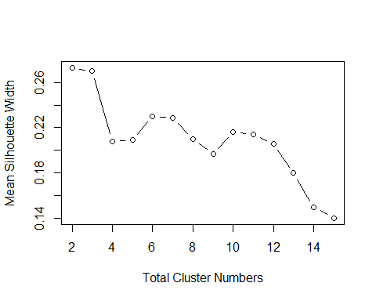

# Perform hierarchical clustering (Let's choose k=3 based on the Silhouette Method)  
fit <- hclust(dist(ps), method = "ward.D2")  
clus_labels <- cutree(fit, k = 3)  
  
# Plot the dendrogram  
plot(fit)

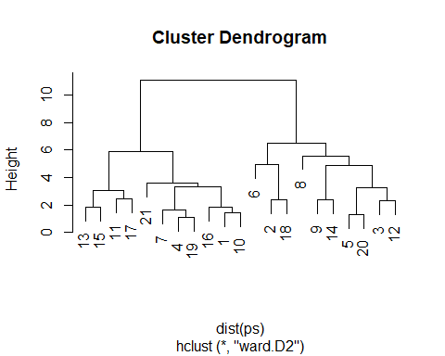

# Part b:  
  
# Summarize clusters by median  
cluster_summary <- aggregate(ps, by = list(clus_labels), FUN = median)  
print("Cluster Summary:")

## [1] "Cluster Summary:"

print(cluster_summary)

## Group.1 Market_Cap Beta PE_Ratio ROE ROA Asset_Turnover  
## 1 1 0.2762415 -0.2559560 -0.2429088 0.3450295 0.8429577 0.4612656  
## 2 2 -0.6953818 -0.4507051 1.9029802 -0.8548399 -0.9422871 -0.4612656  
## 3 3 -0.9393967 0.4840907 -0.3287443 -0.7089994 -0.6979905 -0.4612656  
## Leverage Rev_Growth Net_Profit_Margin  
## 1 -0.3912841 -0.4354459 0.7474438  
## 2 -0.3016910 -0.3811391 -1.5536671  
## 3 0.4406517 1.2163867 -0.4259704

# Part c:  
  
# Add cluster assignment to the original dataframe  
df$Cluster <- clus_labels  
  
pattern_median_rec <- aggregate(Median_Recommendation ~ Cluster, data = df, function(z) names(which.max(table(z))))  
pattern_location <- aggregate(Location ~ Cluster, data = df, function(z) names(which.max(table(z))))  
pattern_exchange <- aggregate(Exchange ~ Cluster, data = df, function(z) names(which.max(table(z))))  
  
print("Patterns in additional variables:")

## [1] "Patterns in additional variables:"

print(pattern_median_rec)

## Cluster Median_Recommendation  
## 1 1 Hold  
## 2 2 Hold  
## 3 3 Moderate Buy

print(pattern_location)

## Cluster Location  
## 1 1 US  
## 2 2 CANADA  
## 3 3 US

print(pattern_exchange)

## Cluster Exchange  
## 1 1 NYSE  
## 2 2 NYSE  
## 3 3 NYSE

# Part d:  
  
# Naming the clusters based on interpretation and pattern  
cluster_names <- c("High Growth, Emerging", "Stable, Low Leverage", "Diverse, High Profit")  
df$Cluster_Name <- as.factor(cluster_names[df$Cluster])  
  
# Show the first few rows of df to confirm cluster assignment and naming  
head(df)

## Symbol Name Market_Cap Beta PE_Ratio ROE ROA Asset_Turnover  
## 1 ABT Abbott Laboratories 68.44 0.32 24.7 26.4 11.8 0.7  
## 2 AGN Allergan, Inc. 7.58 0.41 82.5 12.9 5.5 0.9  
## 3 AHM Amersham plc 6.30 0.46 20.7 14.9 7.8 0.9  
## 4 AZN AstraZeneca PLC 67.63 0.52 21.5 27.4 15.4 0.9  
## 5 AVE Aventis 47.16 0.32 20.1 21.8 7.5 0.6  
## 6 BAY Bayer AG 16.90 1.11 27.9 3.9 1.4 0.6  
## Leverage Rev_Growth Net_Profit_Margin Median_Recommendation Location Exchange  
## 1 0.42 7.54 16.1 Moderate Buy US NYSE  
## 2 0.60 9.16 5.5 Moderate Buy CANADA NYSE  
## 3 0.27 7.05 11.2 Strong Buy UK NYSE  
## 4 0.00 15.00 18.0 Moderate Sell UK NYSE  
## 5 0.34 26.81 12.9 Moderate Buy FRANCE NYSE  
## 6 0.00 -3.17 2.6 Hold GERMANY NYSE  
## Cluster Cluster_Name  
## 1 1 High Growth, Emerging  
## 2 2 Stable, Low Leverage  
## 3 3 Diverse, High Profit  
## 4 1 High Growth, Emerging  
## 5 3 Diverse, High Profit  
## 6 2 Stable, Low Leverage